**3. Given a network address of 10.0.0.0/24, divide it into 4 equal subnets.**

**Calculate the new subnet mask.**

**Determine the valid host range for each subnet.**

**Assign IP addresses to devices in Packet Tracer and verify connectivity.**

Given Network: 10.0.0.0/24

Subnet mask of /24: 255.255.255.0

Total number of IPs in /24: 256

To divide into 4 equal subnets, we borrow 2 more bits from the host portion.

* Original host bits in /24: 8 bits
* Borrowing 2 bits → New subnet mask: /26 (255.255.255.192)
* Number of subnets created: 4
* Hosts per subnet: 64−2=62 (Subtracting network and broadcast addresses)

**First subnet:**

* Network address: 10.0.0.0/26
* Usable host range: 10.0.0.1 - 10.0.0.62
* Broadcast address: 10.0.0.63

**Second subnet:**

* Network address: 10.0.0.64/26
* Usable host range: 10.0.0.65 - 10.0.0.126
* Broadcast address: 10.0.0.127

**Third subnet:**

* Network address: 10.0.0.128/26
* Usable host range: 10.0.0.129 - 10.0.0.190
* Broadcast address: 10.0.0.191

**Fourth subnet:**

* Network address: 10.0.0.192/26
* Usable host range: 10.0.0.193 - 10.0.0.254
* Broadcast address: 10.0.0.255

**Setting up Packet Tracer:**

* Connected four PCs, each in a different subnet, to separate switches.
* Connected the switches to two routers using FastEthernet0/0 and FastEthernet0/1.
* Linked the two routers via a Serial connection and assigned a unique /30 subnet for the link.
* Configured the routers with static routes to enable communication between the different subnets.
* Assigned IP addresses and default gateways to each PC according to its respective subnet:
* PC1: 10.0.0.2/26 (Subnet 1)
* PC2: 10.0.0.66/26 (Subnet 2)
* PC3: 10.0.0.130/26 (Subnet 3)
* PC4: 10.0.0.194/26 (Subnet 4)
* Performed a ping test from PC1 (10.0.0.2) to PC4 (10.0.0.194).
* Output: Ping was successful, confirming that all subnets are correctly connected and routing is working properly.

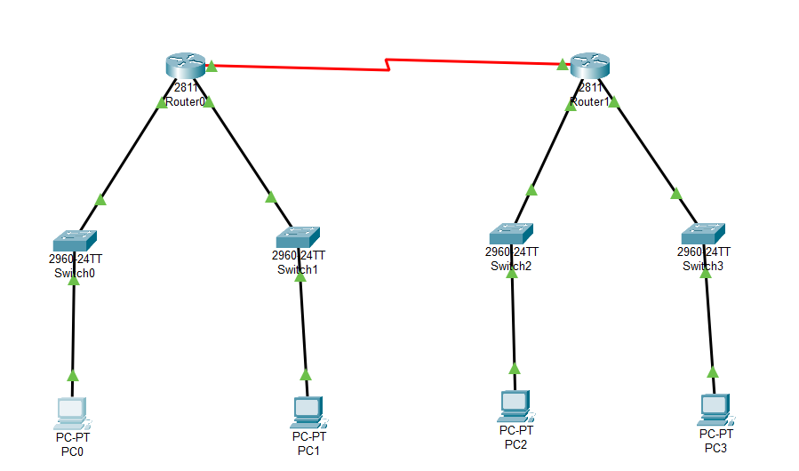

**Ping from PC0 (10.0.0.2) to PC3 (10.0.0.194): The ping is successful**

